The Grand Challenge Initiative - Cusp

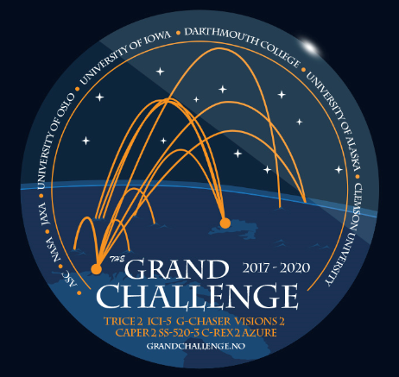

Source: www.grandchallenge.no

A Grand Challenge Initiative (GCI) is a large-scale international collaboration for targeting advancement in specific, fundamental issues in space and earth science. The GCI concept was initiated and has been led by the Andøya Space Center (ASC) and the University of Oslo. Development of the GCI concept has culminated in the first GCI program - “GCI-Cusp” - to determine the multi-scale physics of heating and precipitation in the ionosphere specific to the geomagnetic cusp region.

The GCI-Cusp program is a coordinated experimental and theoretical research using ground based instruments, modeling, sounding rocket investigations, and satellite based instruments. The programmatic core of the GCI-Cusp program is a series of sounding rocket missions independently conceived and developed through the respective space exploration agencies of the US, Norway and Japan.

The core GCI-Cusp observational activities will be conducted in the high northern latitude region surrounding the Svalbard archipelago in the winters of 2018/19 and 2019/20.

The GCI-Cusp sounding rocket missions will be launched from the ASC and Svalrak launch sites while simultaneously gathering data from all other platforms available to study the targeted Cusp and related phenomena.

5 rockets are planned in 2019:
CAPER-2 (January 2019 from ASC over Svalbard)
C-REX-2 (November/December 2019 from Andøya over Svalbard)
ICI-5 and CHI (November/December 2019 from Svalrak, Ny-Ålesund)
SS520-3 (from Svalrak, Ny-Ålesund, time TBD)

CAPER-2: Cusp Alfvèn and Plasma Electrodynamics Rocket
CAPER-2 investigates how auroral particles can be accelerated via Alfvén waves, oscillating, low-frequency waves, accelerate these particles.

CHI: Cusp Heating Investigation
CHI will measure flow of plasmas and neutral gasses in the cusp, testing the current models of how they interact with one another and become heated and accelerated in the process.

C-REX-2 : Cusp-Region Experiment-2
C-REX-2 will measure winds and ion velocity around 400 km in altitude in cusp to track causes of increased densities there. The mission differentiates between possible causes such as changes in wind, temperature, or ion velocity

ICI-5 : Investigation of Cusp Irregularities-5
Turbulent hot patches of dense plasma exist inside the cusp auroral region. ICI-5 seeks to explore the physical drivers of plasma turbulence, determine the size of the eddy structures, and explore how these plasma structures disturb radio signals. ICI-5 is funded through the SIOS InfraNor project.

JAXA SS-520-3
SS-520-3 mission investigates the wave-particle interactions high in the Earth’s atmosphere heats oxygen to escape the planet

Launch condition:
In common, all these rockets will be launched through and active cusp, i.e. intensified solar wind coupling to Earth’s Atmosphere, visualized in the daytime auroras above Svalbard. New moon periods are chosen in order to get high quality auroral observations

GCI -Cusp offers collaboration opportunities:
There is no room for more instruments onboard the rockets. However, the GCI-Cusp rocket team invites new members to join and contribute. The 2018 SIOS infrastructure access call supports initiatives to team in with:
- Observations: To support the rocket launches with ground based observations (all-sky auroral cameras, Fabry-Perrot interferometers, EISCAT Svalbard Radar, GNSS scintillation receivers, etc.). Bring in your own instrument or take part in operating existing instruments. This is needed both for deciding the time of launch, and to frame the geophysical context of the detailed rocket observations.
- Intellectual capacity: Become part of the rocket science team; either be placed in Longyearbyen or in Ny-Ålesund. Task may be to prepare data products aiding to rocket PI to decide the optimal time for launch, and thus be well prepared to take active part in the data analysis and the research to follow. It is agreed that the GCI Cusp data will be publically available through the SIOS data center.

Contact: Dr. Joran Moen, GCI-Cusp Project Scientists (Norway – University of Oslo)
jmoen@fys.uio.no

https://www.jpl.nasa.gov/infographics/infographic.view.php?id=12179

